PokeWorks Project Scope

**Objective**: Provide users with a reference utility for basic gameplay information such as evolution conditions, move sets, items, etc. as well as specialized utilities for specific game mechanics.

# Development Environment

The only core objective is to develop a Progressive Web Application (PWA) built as a Cache-First Network. The purpose being to allow for multi-device compatibility, available inherently with PWA. This also provides the application with the ability to work offline in conditions with poor network availability or devices not capable of consistent network connection.

Due to the offline capabilities of the application, most processes will need to be programmed in JavaScript. Libraries will need to be developed in order to appropriately process the raw data. Currently only Vanilla JavaScript and jQuery are utilized for the core data processing.

# Reference Data

All reference data is primarily driven by vanilla data from PokeAPI (<https://pokeapi.co/>). Some supplementary datasets can be developed to fill gaps in the API’s dataset.

Viewing a Pokemon’s “profile” should provide the following information with regard to gameplay:

* Sprite Image(s)
  + Cycle through available images in the future
* Pokedex ID #
  + Currently National ‘Dex
  + Allow user configuration in the future
* Species Name
* Evolutionary Form(s)
  + Include list of ALL evolution conditions (level, environment, item, etc.)
  + Navigation amongst evolutionary chain
* Base Stats

# Utilities

This section will outline a list of game mechanic utilities that the app must provide.

## Base Stat Comparison

Provides the user with the ability to visually compare base stats between two selected Pokemon. [See this CodePen Pen as a reference](https://codepen.io/tbm0115/full/MqMdMJ/).

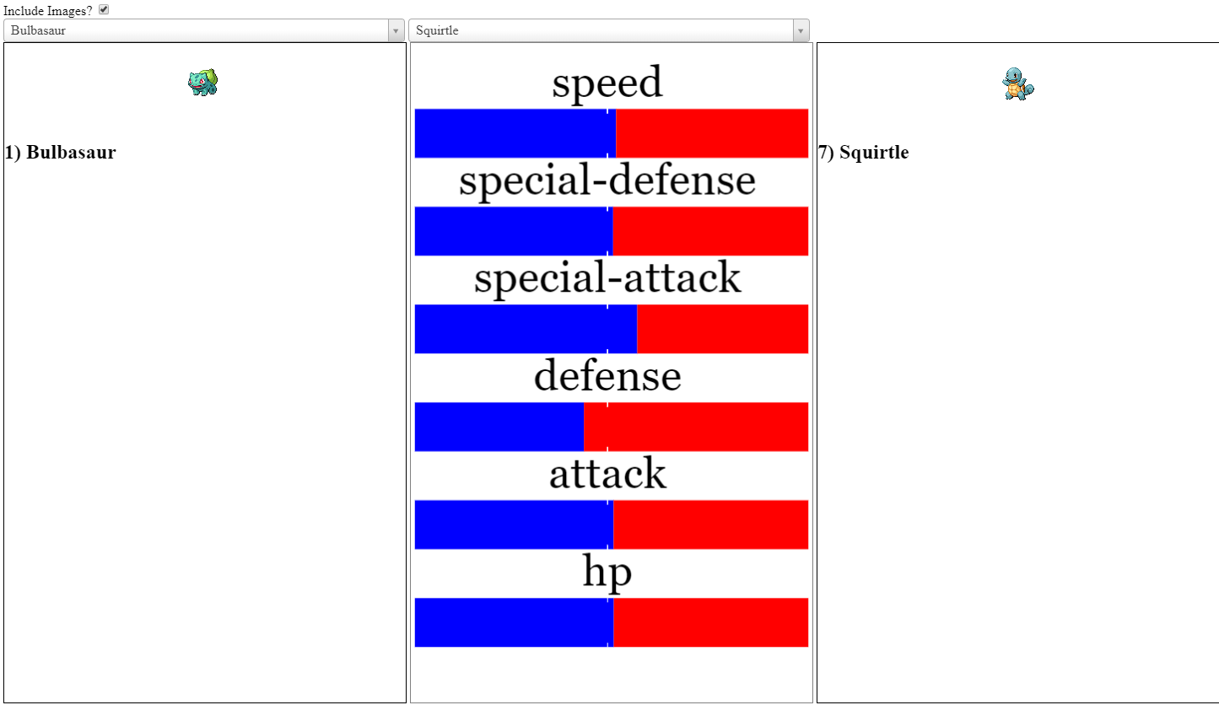

Future implementations could provide searching capabilities. For example, searching for Pokemon with a Speed greater than the selected.

## Step Path Calculator

This goal of this calculator is to provide the user with the means of generating a nominal path of steps based on a Current Position, a Destination Position, and algorithm based on things like Poison Status or Safari Zone steps remaining. The user will be presented with a grid that will represent their current screen where they “draw” basic boundaries and specify their Current Position and the Destination Position.

**Use-Cases**:

* Trainer Escape Glitch (ie. [RBY Veridian Forest](https://imgur.com/gallery/cSSqG))
* Poison Status
* Egg Hatching
* Safari Zone

## Voltorb Flip Calculator

A commonly available calculator to solve the minigame “Voltorb Flip”. Example: <http://www.voltorbflip.com/>